|  |  |
| --- | --- |
|  | **Computer Organization & Assembly Language**  **BSCS-3**  **Department of Computer Science**  **Bahria University, Lahore Campus** |

**Assignment: [1]**

Date: Week 6, 31st March 2023

Name:

Roll No:

|  |  |  |  |
| --- | --- | --- | --- |
| **Evaluation of CLO** | **Question Number** | **Marks** | **Obtained Marks** |
| **CLO2: Develop programming concepts of Assembly language.** | 1 | 5 |  |
| 2 | 5 |  |
| 3 | 5 |  |
|  |  |  |
| **Total Marks** | | **15** |  |

**Question 1: [Marks: 5]**

Implement a subprogram that prompt the user for 3 numbers, finds the median (middle value) of the 3, and returns that value to the calling program.

CODE:

.data

n1: .asciiz "Enter number 1: "

n2: .asciiz "Enter number 2: "

n3: .asciiz "Enter number 3: "

mid: .asciiz "The median is: "

.text

main:

la $a0, n1

li $v0, 4

syscall

li $v0, 5

syscall

move $t0, $v0

la $a0, n2

li $v0, 4

syscall

li $v0, 5

syscall

move $t1, $v0

la $a0, n3

li $v0, 4

syscall

li $v0, 5

syscall

move $t2, $v0

#if part

sge $s1, $t0, $t1

sle $s2, $t0, $t2

and $s0, $s1, $s2

beqz $s0, checkNum1

jal printNum1

j end

checkNum1:

sge $s1, $t0, $t2

sle $s2, $t0, $t1

and $s0, $s1, $s2

beqz $s0, else_if

jal printNum1

b end

else_if:

sge $s1, $t1, $t0

sle $s2, $t1, $t2

and $s0, $s1, $s2

beqz $s0, checkNum2

jal printNum2

b end

checkNum2:

sge $s1, $t1, $t2

sle $s2, $t1, $t0

and $s0, $s1, $s2

beqz $s0, else

jal printNum2

b end

else:

#print num3

la $a0, mid

li $v0, 4

syscall

add $a0, $zero, $t2

li $v0, 1

syscall

b end

printNum1:

la $a0, mid

li $v0, 4

syscall

add $a0, $zero, $t0

li $v0, 1

syscall

b end

printNum2:

la $a0, mid

li $v0, 4

syscall

add $a0, $zero, $t1

li $v0, 1

syscall

b end

end:

li $v0, 10

syscall

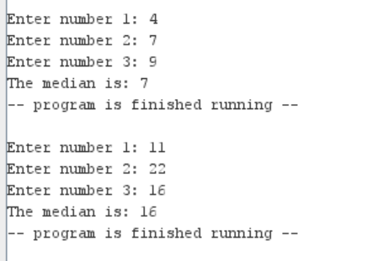

**Question 2: [Marks: 5]**

Write a recursive program to calculate factorial numbers. Use the definition of factorial as F(n) = n * F(n-1).

CODE:

.text

main:

la $a0, input1

li $v0,4

syscall

li $v0,5

syscall

move $s0, $v0

li $t0, 1

jal fact1

move $t0, $v0

jal display

fact1:

addi $sp, $sp, -8

sw $ra, 0($sp)

sw $s0, 4($sp)

beq $s0, $t0, return

addi $s0, $s0, -1

jal fact1

lw $t0, 0($sp)

mul $v0, $s0, $v0

return:

lw $s0, 4($sp)

lw $ra, 0($sp)

addi $sp, $sp, 8

jr $ra

display:

la $a0,fl

li $v0,4

syscall

move $a0,$s0

li $v0,1

syscall

la $a0,f2

li $v0,4

syscall

move $a0 , $t0

li $v0,1

syscall

j end

end:

li $v0,10

syscall

.data

input1: .asciiz "Enter The number : "

fl: .asciiz "Factorial of "

f2: .asciiz " is : "

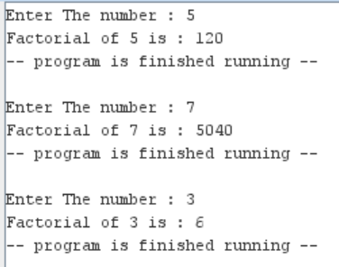

**Question 04:** **[Marks: 5]**

Prompt the user for a number from 3.100, and determine the prime factors for that number. For example, 15 has prime factors 3 and 5. 60 has prime factors 2, 3, and 5. You only have to print out the prime factors, not how many times they occur (for example, in the number 60 2 occurs twice).

CODE:

.text

main:

la $a0, input1

li $v0, 4

syscall

li $v0, 5

syscall

move $s0 , $v0

li $t0, 2

li $t3,1

jal display

jal checkIfPrime

j end

display:

la $a0, prime

li $v0,4

syscall

li $v0,1

move $a0,$s0

syscall

la $a0, is

li $v0,4

syscall

jr $ra

checkIfPrime:

beq $s0, 1, end

div $s0, $t0

mfhi $t1

beq $t1, 0, output

add $t0, $t0, 1

jal checkIfPrime

output:

div $s0, $s0, $t0

beq $t0,$t3 checkIfPrime

li $v0, 1

move $a0, $t0

syscall

li $v0,4

la $a0, space

syscall

move $t3,$t0

jal checkIfPrime

end:

li $v0,10

syscall

.data

input1: .asciiz "Enter a number: "

prime: .asciiz "The Prime Factors of "

is: .asciiz " is: "

space: .asciiz " "

